WEB-BASED PUBLIC TRANSPORT RIDERSHIP PREDICTION AND TRAVEL PLANNING SYSTEM

NURNISRIZA BINTI DE AFENDI

FACULTY OF COMPUTING AND INFORMATICS UNIVERSITY MALAYSIA SABAH
2026

WEB-BASED PUBLIC TRANSPORT RIDERSHIP PREDICTION AND TRAVEL PLANNING SYSTEM

NURNISRIZA BINTI DE AFENDI

THESIS SUBMITTED IN PARTIAL FULFILLMENT FOR THE DEGREE OF BACHELOR OF COMPUTER SCIENCE WITH HONOURS
(DATA SCIENCE)

FACULTY OF COMPUTING AND INFORMATICS UNIVERSITY MALAYSIA SABAH

NAME : NURNISRIZA BINTI DE AFENDI
MATRIC NUMBER : BI23110047
TITLE : WEB-BASED PUBLIC TRANSPORT RIDERSHIP PREDICTION AND TRAVEL PLANNING SYSTEM
DEGREE : BACHELOR OF COMPUTER SCIENCE WITH HONOURS
(DATA SCIENCE)
VIVA’S DATE : DD MONTH 2026



CERTIFIED BY;

1. SUPERVISOR Signature
DR. ERVIN GUBIN MOUNG

DECLARATION

I hereby declare that the material in this thesis is my own except for quotations, equations, summaries and references, which have been duly acknowledged.

DD MONTH 2026 
NURNISRIZA BINTI DE AFENDI BI23110047

ACKNOWLEDGEMENT
To begin with, I would like to say that I am incredibly thankful to Allah SWT in all of his blessings, guidance and strength during the implementation of this Final Year Project. I would not have succeeded in making this thesis without His grace.
My utmost satisfaction goes to my supervisor, Dr. Ervin Gubin Moung, whose guidance, invaluable advice, patience as well as encouragement were very instrumental in the preparation of this project. His assisting skills and competence have aided me to enhance the technical as well as academic front of this study.
The faculty of Computing and Informatics, University Malaysia Sabah, special lecturers of the faculty are also my special thanks as they have provided knowledge and skills that I have acquired over the period of my studies. They have taught me a lot of good which has given me a solid starting point to pursue this project.
Another thing that I am thankful to my family is their untainted prayers, emotional support, understanding and motivation. They have inspired me to struggle and stay determined to accomplish this research.
Moreover, I must also extend my gratitude to my friends and colleagues in the learning environment who have aided, directly or indirectly, ideas, help and moral support as I undertook the completion of this project. The fact that they cooperate and are encouraging is appreciated.
Lastly, I wish to recognize everyone and everyone involved in the success of the project in one way or another. Hopefully, this project can shed some useful information on the topic of the public transport planning process, as well as provide evidence that data science and machine learning can facilitate the resolution of the actual transportation problems.

NURNISRIZA BINTI DE AFENDI
DD MONTH 2026 (WEEK 14 PRESENTATION DATE)

ABSTRACT
Transportation is a significant factor in facilitating mobility and minimising road congestion leading to more sustainable urban development. Nevertheless, the demand of the passengers for the services of the public transport can vary either on the peaks or off-peaks resulting in over-saturations, under-utilization of resources and inconvenience to passengers. Railway services which include the Electric Train Service (ETS) in Malaysia, might not have a steady demand in ridership and therefore, passengers like students would not be able to plan their rides effectively. It has been previously demonstrated that travel demand prediction can help transport operators and users make more informed choices by making better predictions and demand-conscious planning (Wang et al., 2018; Zhang et al., 2011).
This is a project that suggests the implementation of a Web-Based Public Transport Ridership Prediction and Travel Planning System which examines previous ridership data and the future demand of the passengers. The primary goals of this project are to examine the historical ETS ridership trends in Malaysia, create a machine learning model to predict the number of people traveling, determine the busiest and slowest travel time and visualize the ridership data to interpret and make improved decisions.
The project methodology entails various stages such as data collection, pre-processing data, exploratory data analysis, feature engineering, model development, evaluation and web-based system implementation. Data about the transport will be cleaned and converted into features that will be useful such as route, day of the week, time of travel, date. A regression-based model of machine learning will be taken into consideration to project the passenger ridership. The forecasted value will be categorized into the demand groups of low, medium and high to enhance the user interpretation. Preprocessing of data and the preparation of the features is an important stage of the preprocessing of the data due to the significant impact the quality of the input data has on the performance of the predictive model (Kuhn & Johnson, 2013; Géron, 2022).
The proposed system has a few modules such as route selection, travel input, historical data processing, ridership prediction, demand classification, result visualization, travel recommendation, and trend analysis. The visualization section should show graphs and charts that enable users to recognize traveling tendencies with less effort whereas the recommendation section will recommend the appropriate times to travel, ensuring that these are not the times of high demand. Predictive forecasting results need to be translated into practical insights by using visualization and user-friendly decision support tools (Knaflic, 2015).
The projected result of this project is the development of a working web-based system that could facilitate passengers with their trip planning in a much more efficient way and could aid in the unveiling of trends in ridership that could be applied in further transport planning. All in all, this work displays the way data science and predictive analytics can be utilized in the context of the work on the public transportation issues and how well they can enhance the process of traveling plans and decisions.

ABSTRAK
SISTEM BERASASKAN WEB UNTUK RAMALAN PERMINTAAN PENUMPANG DAN PERANCANGAN PERJALANAN PENGANGKUTAN AWAM
Pengangkutan merupakan faktor penting dalam memudahkan mobiliti serta mengurangkan kesesakan jalan raya, sekaligus menyumbang kepada pembangunan bandar yang lebih mampan. Walau bagaimanapun, permintaan penumpang terhadap perkhidmatan pengangkutan awam boleh berubah antara waktu puncak dan luar puncak, yang mengakibatkan kesesakan berlebihan, penggunaan sumber yang tidak optimum, serta ketidakselesaan kepada penumpang. Perkhidmatan kereta api seperti Electric Train Service (ETS) di Malaysia juga menghadapi ketidaktentuan dalam permintaan penumpang, menyebabkan pengguna terutamanya pelajar sukar merancang perjalanan mereka dengan berkesan. Kajian terdahulu menunjukkan bahawa ramalan permintaan perjalanan dapat membantu pengendali pengangkutan dan pengguna membuat keputusan yang lebih tepat melalui perancangan yang lebih berasaskan permintaan (Wang at al., 2018; Zhang et al., 2011).
Projek ini mencadangkan pembangunan sebuah Sistem Berasaskan Web Untuk Ramalan Permintaan Penumpang dan Perancangan Perjalanan Pengangkutan Awam yang menganalisis data pengangkutan terdahulu untuk meramalkan permintaan penumpang pada masa hadapan. Objektif utama projek ini adalah untuk menganalisis trend pengangkutan ETS di Malaysia, membangunkan model pembelajran mesin bagi meramalkan jumlah penumpang, mengenal pasti waktu perjalanan paling sibuk dan paling kurang sibuk, serta memvisualisasikan data pengangkutan bagi memudahkan interpretasi dan menyokong pembuatan keputusan yang lebih baik.
Metodologi projek ini melibatkan beberapa peringkat utama seperti pengumpulan data, prapemprosesan data, analisis penerokaan data, kejuruteraan ciri, pembangunan model, penilaian model dan pelaksanaan sistem berasaskan web. Data pengangkutan akan dibersihkan dan ditukarkan kepada ciri-ciri yang relevan seperti laluan, hari dalam seminggu, masa perjalanan dan tarikh. Model pembelajaran mesin berasaskan regresi akan digunakan untuk meramalkan jumlah penumpang. Nilai ramalan tersebut kemudiannya akan dikategorikan kepada tahap permintaan iaitu rendah, sederhana dan tinggi bagi meningkatkan kefahaman pengguna. Prapemprosesan data dan penyediaan ciri merupakan langkah yang sangat penting kerana kualiti data input memberi kesan yang signifikan terhadap prestasi model ramalan (Kuhn & Johnson, 2013; Géron, 2022).
Sistem yang dicadangkan terdiri daripada beberapa modul utama seperti pemilihan laluan, input perjalanan, pemprosesan data sejarah, ramalan pengangkutan, pengelasan permintaan, visualisasi keputusan, cadangan perjalanan dan analisis trend. Bahagian visualisasi akan memaparkan graf dan carta yang membantu pengguna memahami corak perjalanan dengan lebih mudah, manakala modul cadangan perjalanan akan mencadangkan waktu perjalanan yang sesuai dengan mengelakkan tempoh permintaan tinggi. Hasil ramalan perlu diterjemahkan kepada maklumat yang praktikal melalui penggunaan visualisasi dan alat sokongan keputusan yang mesra pengguna (Knaflic, 2015).
Hasil yang dijangkakan daripada projek ini ialah pembangunan sebuah sistem berasaskan web yang berfungsi sepenuhnya yang dapat membantu penumpang merancang perjalanan dengan lebih efisien serta mendedahkan corak permintaan penumpang yang boleh dimanfaatkan untuk perancangan pengangkutan pada masa hadapan. Secara keseluruhannya, projek ini menunjukkan bagaimana data sains dan analitik ramalan dapat diaplikasikan dalam menangani isu pengangkutan awam serta meningkatkan kecekapan dalam perancangan perjalanan dan pembuatan keputusan.

TABLE OF CONTENTS

DECLARATION IV
ACKNOWLEDGEMENT V
ABSTRACT VI
ABSTRAK VIII
TABLE OF CONTENTS X
LIST OF TABLES XII
LIST OF FIGURES XIII
CHAPTER 1 1
INTRODUCTION 1
1.1 Introduction 1
1.2 Problem Background 1
1.3 Problem Statement 2
1.4 Project Objective 3
1.5 Project Scope 4
1.6 Organization of the Report 6
1.7 Summary 7
CHAPTER 2 8
LITERATURE REVIEW 8
2.1 Introduction 8
2.2 Public Transport Demand Forecasting 8
2.3 Machine Learning Methods for Ridership Prediction 9
2.4 Data Preprocessing and Feature Engineering 11
2.5 Existing Systems and Applications 12
2.6 Summary 13
CHAPTER 3 15
METHODOLOGY 15
3.1 Introduction 15
3.2 Development Methodology 15
3.3 Requirements Specification 16
3.3.1 Functional Requirements 16
3.3.2 Non-Functional Requirements 17
3.4 Data Collection 17
3.5 Data Preprocessing and Feature Engineering 18
3.6 Model Development and Evaluation 19
3.7 System Architecture and Design 20
3.7.1 System Architecture 20
3.7.2 Use Case Diagram 23
3.7.3 Entity-Relationship Diagram 24
3.7.3 Data Flow Diagram 25
3.7.4 Data Processing Pipeline 25
3.8 System Implementation 27
3.9 Project Timeline & Summary 27
3.9.1 Project Timeline 27
3.9.2 Summary 28

LIST OF TABLES

TABLE 1. 1: Overviews The Project Scope with The Major Modules 5
TABLE 2. 1: Machine Learning Algorithm for Ridership Prediction 11
TABLE 2. 2: Existing Systems and Applications 13
TABLE 3. 1: Functional Requirements 16
TABLE 3. 2: Non-Functional Requirements 17
TABLE 3. 3: Entity Description 24

LIST OF FIGURES
Figure 1: System Architecture 21
Figure 2: Detailed System Architecture 22
Figure 3: Use Case Diagram 23
Figure 4: Entity-Relationship Diagram (ERD) 24
Figure 5: Data Flow Diagram (DFD) 25
Figure 6: Data Processing Pipeline 26
Figure 7: Gantt Chart of Project Timeline 28

CHAPTER 1

INTRODUCTION

1.1 Introduction
Public transport is significant to facilitate the daily mobility, alleviate traffic congestion and facilitate sustainable development of urban areas. The Electric Train Service (ETS) is a major rail service in Malaysia which is used by the people as an intercity mode of transportation. Nonetheless, the demand of passengers in the transport system is usually affected by the hour, day, route, weekends, holidays and seasonal traffic. Such fluctuations may cause overcrowding during peak hours, scarcity of tickets and poor travel planning to passengers.
As more historical data on transport becomes accessible, machine learning can be used to detect ridership trends and forecast passenger demand in the future. By predicting ridership, users can make improved travel choices and service planning can also be of valuable insight. In the present project, the web-based predictive ridership and travel planning of public transport will be developed in Malaysia using historical ETS ridership data. The system will forecast the number of passengers, categorize the level of demand and offer easy traveling advice based on forecasted conditions.
In addition to generating prediction results, the system would also contain data visualizations like charts and heatmaps to enable users to gain a deeper understanding of travel patterns, routes with the highest traffic and busiest or slowest hours. The project will integrate the data analysis, predictive modeling and web-based system development into a practical application by students, public users and administrators alike. The passengers can then go ahead and book ETS tickets in a convenient way through the KTMB official site in order to match their schedule with the predicted demand.

1.2 Problem Background
The demand of the public transport is not fixed. Certain seasons in the year have high ridership and there are those with low demand. In the case of ETS services the variation can depend on the time of day, day of the week, school holidays, a festive season, route popularity and overall travel habits. High-demand times may result in inconveniences affecting passengers who are unaware of them including sold-out flights, travel congestion or a bad choice of the trip time.
The current solutions of transport information are primarily those that are concerned with schedules, ticketing or non-moving route information. They do not tend to give forecasting of the future demand of ridership among certain time of travels or travel routes. Consequently, the passengers tend to make travelling choices without considering the probability of the demand being low, moderate or high.
Meanwhile, the public open data in Malaysia has provided historical ridership data. ETS hourly origin destination data is used because it has travel demand data per station-pair per time which qualifies it to be analyzed in data analysis and used to predict demand data. The data set is in the most raw form of ETS ridership records that is helpful in analytical and predictive analysis.

1.3 Problem Statement
One of the major challenges facing the public transport system in the Republic of Malaysia especially in the Electric Train Service (ETS) is the inconsistent demand of the passengers that greatly fluctuate during high and low seasons. This fluctuation poses operational inefficiencies as transportation operators find it very difficult to properly resource this situation, thus resulting in overutilization on high demand and underutilization on low demand. This imbalance has many ramifications beyond the beliefs of operation to relate straight away to the experience of passengers who during peak hours find themselves getting crowded resulting in discomfort and inconvenience once on the train and find it challenging to schedule their own travels effectively because of the insensitivity of the demand. This issue is augmented by the fact that there are no available tools which would help passengers predict the level of demand when making travel plans.
The particular difficulties experienced by ETS passengers in Malaysia are lack of awareness in terms of peak time of traveling, which leaves most passengers especially students who buy their tickets without knowing their overcrowding levels. This information blackout frequently results in scenarios where the passenger will get to the stations only to discover that the ticket to their desired departure times are already sold or that they will be travelling under some essentially congestive circumstances. Students are especially susceptible to such uncertainties because they lack much flexibility with their travel dates because of the nature of academic schedules. This failure to make a knowledgeable decision on the timing of travel with consideration to the expected levels of demand is a major flaw in services provided to passengers at the moment and they are left to adhere to the historical rules of thumb instead of based on data-predictions.
The lack of a system that predicts levels of ridership with historical data being used is a definite void in the existing transportation service system. Even though there are an adequate amount of data on historical ridership patterns, this information has not been leveraged well to offer any predictive service to the passengers. Subsequently, an analysis mechanism capable of scrutinizing historical ETS ridership statistics, developing predictive models and delivering actionable details among others is required to enable the passengers to plan their trips more efficiently. Such a system would not just advantage the passenger in making informed travel choices but would serve as a great source of information to transportation operators as to the patterns and trends of demand.

1.4 Project Objective
The main aim of this project is to come up with a public transport ridership prediction and travel planning system based on ETS service within Malaysian, web-based. It will be used as a decision-support tool that will allow passengers to make more informed decisions about which time to travel, basing it on the forecasted level of demand. The project will help solve the identified problem through the development of a convenient platform that will convert historical ridership data into predictable information that can be acted upon. The detailed aims of this project are as follows.
The first one is concerned with review of the past ETS ridership data in Malaysia to comprehend current trends and patterns. It will include the analysis of the ridership data that have been compiled over a period in order to find out predictable trends concerning changes across time, route traits, and trends across the seasons. Analysis will attempt to develop basic knowledge of the variation of ridership with respect to time, days and routes, which will form on predictive modeling activities.
The second one is to come up with a machine learning model that can make predictions as to the number of passengers in the future based on the past trends and features. In this model, the historical data analyzed will be used to develop predictive abilities that are capable of forecasting the levels of ridership in specific combinations of route, date and time. To obtain acceptable prediction accuracy, the feature engineering and model selection in the elaboration of such a model should be conducted carefully.
The third goal will be to determine high and low periods of travel in the data analyzed. This means defining the normal demand rates in the various time dimensions and determining the parameters of how the demand periods can be contrasted as low, middle or high demand periods. These patterns can be studied and learn much on how to not only make predictions but also offer travel advice to people.
The fourth goal is the visualization of the ridership trends to make it possible to understand and make a decision. This involves developing charts, graphs and other graphic illustrations that can communicate ridership patterns and prediction outcomes easily. Quality visualization will turn the complicated data into a meaningful action to be undertaken by end users easily.

1.5 Project Scope
The aim of this project is to develop a web-based public transport ridership prediction and travel planning system using past transport related data. The project is restricted to passenger demand pattern analysis and prediction using availed historical characteristics like route, date and time. It is a decision-support tool that is designed to be used by users and does not substitute official ticketing or railway management systems.
There are eight major modules of the project. The first module is the Route Selection, which the user selects an origin and destination and indicates the existing routes. The second module is Travel Input which customers pick date and time information about their planned trip. The third module is the Historical Data Processing which this entails cleaning data and forming features that can be used to train models. Ridership Prediction is the fourth module, in which the system predicts the number of passengers based on a machine learning model. The fifth module is the Demand Classification module, in which the values are predicted and put into category which include low, medium and high demand. The sixth module is the Result Visualization that shows the results of the prediction in graphs and charts. The seventh module is Travel Recommendation that proposes the appropriate travel seasons depending on anticipated demand. The eighth module is Trend Analysis that shows peak hours and routes to optimize the knowledge of the ridership behavior where it will display peak hours and busy routes.
This project is not about live ticket availability integration, live track of train operation and live booking. The quality, quantity and relevance of the historical dataset to be utilized in the study will determine the performance of the prediction. Hence the system is more geared towards forecasting and planning support and not operational control.
TABLE 1. 1: Overviews The Project Scope with The Major Modules
Module | Description | Scope Boundaries
Route Selection | User chooses the origin and destination and displays the routes. | No other means of transport, just ETS stations.
Travel Input | User chooses date and time to take a trip. | Up to 3 months in advance.
Historical Data Processing | Preparation of features and data cleaning. | Takes a historical record of usage.
Ridership Prediction | ML model forecasts number of passengers. | According to date, time, characteristics of the route.
Demand Classification | Organises prediction into levels of demand. | Low, Medium, High.
Result Visualization | Visualizes forecast in charts/graphs. | Chart-based presentation only.
Travel Recommendation | Recommends the best timeframes to travel. | Depending on anticipated levels of demand.
Trend Analysis | Board displays peak hours and busy routes. | Historical pattern display.

1.6 Organization of the Report
The study is presented in this report under five chapters which discuss different sections of the project such as introduction to conclusion. Logical flow of the chapters makes sure that all the aspects of interest are covered without disjointed information flow.
Chapter One introduces the project, background and reasoning behind the work, the problem statement, with specifications of the goals that must be attained and the scope that outlines scope limitations within the project. This chapter sets the groundwork to comprehend the further technical activity and contextualizes the context in which the project functions. The organization of the report is also outlined in the chapter in order to provide the reader with a guide to the organization of the document.
Chapter Two will involve an extensive literature review related to the relevant research and the current systems that may apply in the topic of the project. The chapter explores scholarly sources on the subject of prediction of transport demand, methods of machine learning that are used in the transportation domain, preprocessing of data, its visualization and market competitors. The review gives theoretical background and sets the scene of the methodological decisions in the project.
Chapter Three explains the methodology used in this project which shows the systematic procedure that will be followed during data collection to the system implementation. The chapter discusses the data collection techniques, the data preprocessing, data exploratory data analysis, feature development, model creation and selections, evaluation methodology and implementation architecture to the web-based system. This methodological specificity allows reproducing it and gives clarity about the technical implementation of the project.
Chapter Four is the results and discussion part of the project which includes the output results of the system development, the functionality of the prediction models, anticoded results are produced and visualization and the interpretation. The chapter provides evidence of the accomplishment of project goals and comments on the implications of the findings. The chapter also explains the shortcomings and problems that were faced in the implementation of the project.
Chapter Five concludes the work giving conclusions and recommendations on the further work. The chapter recapitulates on the success of the project as well as concludes about the work done and proposes future improvement and development directions. The chapter gives concluding thoughts on how the project is helping to solve the identified problem.

1.7 Summary
In conclusion, the current chapter presented the history and drive of the project at which the aim is to predict the amount of people using public transportation and assist in travel planning using a web-based platform. The chapter also outlined the issue under discussion, the aims to be fulfilled, the scope of the project as well as the structure of the entire report. The project will hopefully lead to smarter and more informed travel planning by using historical data, machine learning, and long-view visualization to do so.

CHAPTER 2

LITERATURE REVIEW

2.1 Introduction
The usage of data science and machine learning in transport and transport has become an important field of study and practice over recent years. The chapter provides an in-depth overview of the associated literature on the topic of the public transport ridership prediction, the machine learning algorithms, data preprocessing techniques and the existing travel planning systems. The methodological decisions and technical approach used in the project are based on the knowledge of what is currently researched and what systems are available. The review explores scholarly literature, business practices and rival systems to determine the environment that this project is to undertake. This chapter groups insights together through synthesis of the findings of various sources to establish the best practices and potential areas of innovation which can be used to develop the proposed system. The literature review is divided into themes that discuss various elements of ridership prediction and travel planning and ends with the capabilities and analysis of systems available.

2.2 Public Transport Demand Forecasting
The problem of the demand forecast in the sphere of public transport has been developing throughout the last several decades, changing its classical statistical background with the capabilities of a more advanced machine learning algorithm that could identify intricate trends in transportation data. The basic assumption that drives the demand forecasting is that the demand of the transportation services is not unpredictable, but a patterned behavior depending on temporal, spatial and exogenous elements. Early methods of demand forecasting were based mainly on statistical techniques like regression analysis and time series models which gave reasonable forecasts in predicting demand that were stable but not in response to non-linear nature of transportation demand. The article by Wang et al. (2018) showed that travel demand forecasting has the potential to implement more informed decisions by the transport operators and users to better predictions and demand-oriented planning to prove the practicality of the forecasting systems. On the same note, Zhang et al. (2011) demonstrated that addition of various sources of information such as historical data, calendar effects and special events may be useful in enhancing accuracy of the forecasts.
Recent demand forecasting methods utilize machine learning algorithms that are capable of selecting the complexity of transportation data coupled with its high dimensionality. Chang et al. (2024) assessed various machine-learning models, such as Adaptive Feature Fusion Network (AFFN), Convolutional Neural Network (CNN), Support Vector Machine (SVM), Random Forest and Relational Graph Convolutional Network (RGCN) to make forecasts on metro passenger movements. Their results showed that although deep learning models had at least a higher predictive accuracy, traditional machine learning models had at least back the benefits of computational efficiency and interpretability. This is especially useful in practical applications, which require models to provide reliable forecasts and at the same time be usable by end users and operators, as this is a trade-off between accuracy and interpretability. Another important aspect of the study was that more sophisticated methods of preprocessing such as outlier detection and data normalization can enhance the robustness of models.
The seasonality and time dependencies of the transportation demand pose challenges as well as opportunities to the forecasting systems. A study by Azimian and Jiao (2024) contrasted various time series forecasting methods on predicting system-wide monthly transit ridership and found that classical and hybrid methods were best in cases where full series data was used, but the TBATS, neural network and hybrid methods each worked best during post-pandemic periods. They showed in their work how the usefulness of forecasting methods can differ greatly in each situation and time, which highlights the importance of applying the right methods to each situation and purpose of prediction by considering the nature of the data and its intended use. The COVID-19 pandemic has radically changed the ridership patterns in transit by generating new issues to forecast the pattern and must be adapted to with distributionally responsive techniques, which could identify and react to the distributional shifts in demand.

2.3 Machine Learning Methods for Ridership Prediction
The choice of relevant machine learning algorithms forms a crucial choice when creating ridership prediction systems. Several different families of algorithms have been used in transportation demand prediction, each possessing unique attributes that allow it to be relevant to various aspects of the prediction task. Classical machine learning methods such as the Random Forest, XGBoost and the Support Vector Regression methods have shown good results in the transportation forecasting. It was revealed that the machine learning algorithms demonstrated better results in comparison with average-based techniques as observed in the study of Caroleo et al. (2024), where the algorithms achieved higher results and gains of up to 50 percent in comparison to the baseline approaches when the uncertainty behind demand is higher. Their work employed around 10 million validations, which were collected in 2019, combining transportation data with some extra information, such as weather conditions and temporal segmentation.
Random Forest algorithms have become especially popular in transportation demand prediction because of their resistance to overfitting, and their capability to deal with large feature spaces. The ensemble quality of Random Forest models, which hybridizes the results of a set of decision trees, offers a natural defense against the variance that plagiarize single-tree models when used on a noisy transport data. On the same note, gradient enhancement strategies like XGBoost have been shown to perform well in transportation prediction tasks with a study conducted by Talusan et al. (2022) displaying that XGBoost-based trip level models had a higher score compared to the baseline statistical models over a complete transit service day. They used several types of data such as transit, weather, traffic, and calendar data that comprised a two-year range to make predictions on trains.
Deep learning methods, namely LSTM (Long Short-Term Memory) networks, have proven to be promising to extract temporal dependencies in transportation data. Shah Zeb et al. (2025) study come up with LSTM-based models to predict daily transit ridership during the COVID-19 pandemic, which has a coefficient of determination (R2) of 0.96 achieved by correlating pandemic interventions with transit ridership. Likewise, Salazar-Cabrera (2025) was able to establish LSTM algorithms yielded the most successful results when used to predict passenger load at major BRT stations, but at the beginning of the results, the algorithms had to be hyperparameter-tuned to achieve acceptable performance. Such results indicate that although deep learning techniques have ample potential, their potential can be fulfilled only with an optimistic approach to the development of a specific system.

TABLE 2. 1: Machine Learning Algorithm for Ridership Prediction
Algorithm | Strengths | Weaknesses | Typical Applications
Random Forest | Resistant to overfitting, can deal with high dimensions. | Less interpretable | Route-level demand
XGBoost | Great precision, works with missing data. | Computationally intensive | Stop-level prediction
LSTM | Captures temporal dependencies | Requires tuning | Time series forecasting
SVM | Works in high dimensions. | Slow for large datasets | Classification tasks
k-NN | Simple implementation | Slow prediction | Baseline comparison
Source: Synthesized from Chang et al. (2024), Caroleo et al. (2024), Talusan et al. (2022), Salazar-Cabrera (2025), Shah Zeb et al. (2025)

2.4 Data Preprocessing and Feature Engineering
Best presentation of results of the prediction to the final users is with considerate visualization and interface design which converts detailed numerical descriptions into actionable statistics. The travel planning systems should be able to display the information in simple formats that allow users make a decision without necessarily having a profound insight into the predictive mechanisms behind them. The principles of the efficient communication of data with the help of visualization were developed as a result of the research by Knaflic (2015) which showed that properly designed graphics can convey patterns in a better way than tables or descriptions. These principles can be directly applied to travel planning systems whereby the objective is to assist users to learn the demand patterns and make sound travel choices.
There are time series plots of demand over time, heatmaps of demand by route and time combinations, bar charts of demand by route or time period, and geographic visualizations of the spatial patterns of transportation data. As an illustration of transportation visualization within the survey regarding ridership, the Government of Malaysia KTMB Explorer dashboard is available providing the possibility to use the site to conduct an exploration of the ridership statistics between any two terminuses of transports KTMB runs. These interactive dashboards enable the users to explore trends of their particular travel requirements, creating more interactive and customized experiences compared to more basic visual representations. The dashboard shows both monthly and daily frequencies and allows analyses at various resolutions in time.
Travel planning decision support tools are not only about visualization but also about recommendations that are viable and active i.e. give advice to that user. This project proposes a recommendation module that will give the best times to travel depending on the estimated demand so that users may not be a user during times of high demand when possible. This will convert forecasts into practical advice to help solve the fundamental issue of the passenger uncertainty on traveling time. The use of proactive guidance has proved useful in assisting users make better decisions with similar recommendation systems within other fields, which justifies the consideration of a recommendation module in the proposed system design.

2.5 Existing Systems and Applications
Multiple existing systems and applications provide travel planning capabilities for public transportation, though none currently offer the ridership prediction and demand classification capabilities proposed in this project. Understanding these existing systems provides context for the project's contribution and helps identify opportunities for differentiation. The KTMB Integrated Ticketing System (KITS) serves as the primary official booking channel for ETS services providing scheduling information, ticket booking and seat selection capabilities. The system enables passengers to search for routes, select origin and destination stations, choose departure dates and times and complete bookings. However, the system does not provide predictive information regarding expected demand levels or recommendations for optimal travel timing.
Third-party applications including KTMB Mobile provide additional channels for booking and travel planning, offering features such as QR code entry and complete itinerary management. These applications improve the booking experience through mobile-optimized interfaces but similarly lack demand prediction capabilities. The focus of existing systems on booking and scheduling reflects their primary function as commercial transaction platforms rather than decision-support tools. The gap between current capabilities and passenger needs for demand information represents the opportunity addressed by this project.
Government open data initiatives have made historical ridership data available through the data.gov.my portal, providing the foundation for analytical and predictive applications. The hourly origin-destination ridership dataset for ETS includes detailed records of passenger movements between station pairs providing the granular data necessary for pattern analysis and prediction. This data availability enables the development of analytical systems that leverage previously inaccessible information. The dataset is updated regularly and available in both CSV and parquet formats, supporting programmatic access for analysis. The combination of open data availability and unmet user needs for prediction capabilities creates clear opportunity for the proposed system.
TABLE 2. 2: Existing Systems and Applications
System | Features | Limitations | Relevance to Project
KITS | Booking, scheduling | No demand prediction | Baseline capability
KTMB Mobile | Mobile booking, QR entry | No prediction | User interface reference
KTMB Explorer | Interactive dashboard | Historical analysis only | Visualization example
Open Data Portal | Historical data access | No prediction | Data source
Source: Compiled from official KTMB systems and Government of Malaysia Open Data Portal (data.gov.my, 2026)

2.6 Summary
A comprehensive literature review and the existing systems that were relevant to the development of ridership prediction and travel planning system have been extensively covered in this chapter. The review has confirmed that forecasts of demand in transport have survived through the years and the use of machine learning solutions in transportation forecast operations has become popular. Various algorithm families such as Random Forest, XGBoost and LSTM have been shown to be effective at various points of the prediction task, algorithm selection depending on the prediction goals and the nature of the data used. Preprocessing and feature engineering are very important steps as the performance of the model largely depends on them but temporal feature engineering is especially relevant to the transportation context.
An analysis of the present systems has revealed that there is an obvious discrepancy between present capabilities and the needs of the passengers. Although booking and scheduling systems are not new, none of them has the demand prediction and travelling suggestion which would allow passengers to make a more prudent choice pertaining to travel moment. The presence of historical ridership data as a result of open data programs by governments forms the basis of predictive application. The project will fill this gap by creating a complex system that involves data analysis, predictive modeling and visualization that is easy to use to aid passenger decision-making.

CHAPTER 3

METHODOLOGY

3.1 Introduction
This chapter outlines the procedure that was used in the development of the web-based ridership prediction and travel planning system. Methodology covers all the stages starting with the data collection and ending with the implementation of the system with enough details that somebody can understand and analyze. The method is based on classic data science practices with the implementation modified to suit the needs of the project. Each stage is introduced and has its objectives, procedures and the reason behind the decision.

3.2 Development Methodology
A Data Science Pipeline methodology, namely based on a modified version of the CRISP-DM (Cross-Industry Standard Process for Data Mining) framework is used in this project. This methodology is selected due to its logical system of approach suitable in machine learning projects in order to be complete in its data processing and model implementation. The pipeline includes a structured methodology: Data Collection, Data Preprocessing, Exploratory Data Analysis, Feature Engineering, Model Training, Model Evaluation, System Implementation.
This approach is also different to traditional Waterfall methodology which is used to make assumptions about requirements that are fixed, rather than being developed in an iterative way. It is also contrasted with Agile methodology where development sprints are short, this pipeline has consecutive stages in which one stage is built out of the other. CRISP-DM is a popular data science framework used in data science projects and shown to be effective in transportation demand prediction applications.
The general process starts with receiving data in the government open data portal and preprocessing to analysed data. Exploratory data analysis builds up knowledge on patterns in the ridership data, guiding feature engineering choices. Machine learning model development learns and tests prediction models. The last stage incorporates all the elements into a working web-based system that can be accessed by the users. This is a gradual but iterative process which guarantees good results keeping the project schedules practical.

3.3 Requirements Specification
The requirements specification will outline the functional requirements and the non-functional requirements of the ridership prediction and travel planning system. These are requirements that help in the process of development and make the system user friendly.

3.3.1 Functional Requirements
Functional requirements specify what the system can and cannot do, what kinds of features it will have. The system is to be comprised of the following functional requirements that the user requirements to enable travel planning assistance.
The system will enable the users to choose an origin station by a list containing all ETS stations. It should have a system whereby the user can choose a destination station in a list of all ETS stations. The system will show routes that exist between the chosen origin and destination. The software will take date entries as inputted by the users into which they plan to travel. The system will use time input by the users of their time of departure. The system will give predictions of the ridership on a chosen route, date, and time. The system will categorize the predicted ridership into levels of demand (Low, Medium, High). The system will show the results of prediction in numeric form. Prediction results shall be given visually in form of charts in the system. The system will give recommendations on traveling which can be taken as the best possible time. This system will show the peak hours on historical basis. The system will show the busy routes by using historical data.
TABLE 3. 1: Functional Requirements
ID | Requirement | Description
FR-01 | Route Selection | User is able to choose ETS station origin and destination.
FR-02 | Travel Input | Fields available: date and time of the planned trip.
FR-03 | Ridership Prediction | System predicts number of passengers.
FR-04 | Demand Classification | System sees prediction as Low/Medium/High.
FR-05 | Result Visualization | Visualization of results in charts and graphs by the system.
FR-06 | Travel Recommendation | System recommends best travel times.
FR-07 | Trend Analysis | System indicates busiest routes and hours.

3.3.2 Non-Functional Requirements
Non-functional requirements explain the quality attributes and limitations, the system must run under. These specifications guarantee functionality of the system and a positive user experience.
Under normal operating conditions, the system will take a response time of 5 seconds to user requests. The system will be available via Web browsers using desktop computers and mobile devices. The system will have easy-to-use interfaces with easy labels and directions. The system will be able to anticipate invalid inputs and provide suitable error messages. The system will be accessible when the operating hours are normal. The system will be done based on a modular maintains system.
TABLE 3. 2: Non-Functional Requirements
ID | Requirement | Description
NFR-01 | Performance | Response time less than 5 seconds
NFR-02 | Usability | Easy to use interface
NFR-03 | Accessibility | Works on desktop and mobile browsers
NFR-04 | Error Handling | Displays clear error messages
NFR-05 | Maintainability | Modular architecture

3.4 Data Collection
The data collection is the stage that forms the basis of all other stages of analysis. The main source of data will be the open data portal of the Malaysian Government (data.gov.my) that serves as the source of hourly data on the origin-destination ridership on the ETS service. This dataset contains comprehensive documentation of the passenger trips between the pairs of the stations where each record comprises the date, time, the starting point station, the destination station and the number of passengers. The data is presented in CSV and parquet format with the latter strongly suggested to be used when providing programmatic access because of the high volume of data.
The variables of the dataset are date (in the form of YYYY-MM-DD), time (in the form of HH:00), origin which is the station where the journey started, destination which is the station where the journey ended, and ridership a number of trips made between the starting point and the end of the trip during the particular hour of the day. This information is based on anonymous transactional information produced by the KTMB Integrated Ticketing System (KITS), the most granular type of ridership information available. This source has been chosen due to its benefits such as offering full coverage of past ridership, being publicly opened and being the sole source of truth that all other ETS ridership data sets are sourced in. With such data, predictive models can be created that have enough historical data to recognize a pattern.

3.5 Data Preprocessing and Feature Engineering
There is data preprocessing to turn raw data collected into clean and consistent formats that are analyzed and to be fed into the model. This stage will deal with typical data quality problems such as missing data, inconsistent format, outliers and duplication. The preprocessing processes are based on the recommended good practices but are modified in order to cater to the unique nature of the transportation ridership data. The model’s performance is immediately dependent upon the quality of input data and preprocessing is the important stage.
The first preprocessing steps are to load data and have basic quality checks on the data dimensions and type of variables. Data cleaning can resolve the quality concerns indicated by the quality of responses and identified problems by implementing specific procedures such as management of missing values, standardization of names of stations, elimination of duplicates and outliers in order to establish whether the identified outliers are true Exploratory data analysis then builds insights to patterns such as temporal patterns by hour, day, and month and route patterns and seasonal changes.
The feature engineering converts the preprocessed data to features that can be used to train machine learning models. The hour of day is represented by both a cyclical and numeric representation (sine and cosine transformations) by temporal features to reflect the circularity attribute of time. They also have day of week encoding and month encoding and calendar features of holidays. Origin and destination stations coded using categorical encodings are route features. Features lagged offer historical short-term prediction. A product of the feature engineering process is a feature matrix which can be trained to obtain a model with each row containing an observation and each column containing a feature.

3.6 Model Development and Evaluation
Development of models developed the predictive capability that is at the heart of the system. This step chooses the right algorithms, and models are trained on engineered features and the performance of models is also evaluated to determine which approach works best. The model building is based on existing machine learning methods optimized to work with transportation forecasting.
Selection of algorithms considers several approaches such as Random Forest regression, XGBoost and Linear Regression as candidates. Random Forest is strong and capable of dealing with mixed features. XGBoost has a potentially high accuracy with gradient boosting as well as reasonably efficient computation. Linear Regression can be used as a comparison to the simplest model to gauge the complexity of complex models as worth the complexity. The algorithm choice-based criteria include the theoretical appropriateness of each algorithm, computation needs and the anticipated lineage of interpretation.
Model training uses the selected algorithms on the prepared feature matrix, training to find the interaction between the feature and the outcome of ridership. It is divided into training and testing sets whereby time-based division is recommended where there is the presence of temporal data to eliminate data leakage. Cross-validation gives strong performance estimates through training and testing processes of various data partitions. Hyperparameter optimization is the process of optimizing the parameters of the model, applied to the particular prediction task, with grid search methods.
Model evaluation involves evaluation and measurement of performance through the use of several measures. Mean Absolute Error (MAE) is used to measure mean error in predictions of the number of passengers. Rootmean Square Error (RMSE) executes bigger errors at a heavier penalty. R-squared (R2) is the percentage of variance that the model represents. When conducting classification tasks that assess the level of demand (Low, Medium, High) the measures of classification performance are the accuracy and F1-score. The assessment stage delivers a completed model that has recorded the performance characteristics that are prepared to be absorbed into the system.

3.7 System Architecture and Design

3.7.1 System Architecture
The system architecture shows the stratified approach of the web-based ridership prediction system. It decouples the frontend interface, a backend processor and a database storage in order to guarantee modularity and scalability. The user input is processed through the front end like the route and travel information and the back end incorporates the data preprocessing, machine learning prediction and visualization modules. Historical ETS ridership records are stored in the database to be useful when making accurate forecasts and decisions.
Three-tier system architecture
Presentation Layer (Frontend)
- Route Selection Form
- Travel Input Form
- Result Display
- Charts & Visualization (Trends)
- Recommendation Display
Application Layer (Backend)
Route  Select | Travel  Input | Result  Display
ML Model (Random Forest)
- Feature Engineering
- Ridership Prediction
- Demand Classification
Data Layer
ETS Data  (Origin-Destination) | Trained Model  (model.pkl)

Figure 1: System Architecture

The system consists of a three-tier system:
- Presentation Layer (Frontend)
- Input/Display interface.
- Handles user interactions
- Backend (Application Layer)
- Processes user requests
- Predicts with ML model.
- Manages data flow
- Data Layer
- Historical ridership database.
- archive ETS ridership data.
- Stores trained model
This characterizes the three levels architecture with depiction of the elements and circulation of data between the user entry and the display of the results.
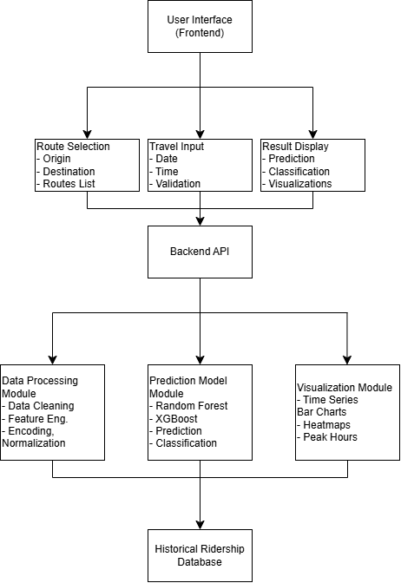
Figure 2: Detailed System Architecture

3.7.2 Use Case Diagram
The use case diagram illustrates the interaction between the users and the system. Although no actors such as passengers or administrators are depicted, there are system functions (like route selection, ridership prediction, demand classification, travel recommendation, etc.) that indicate dependencies between use cases which makes core functionalities connected. This diagram shows the extent of user-system interchanges and services offered.

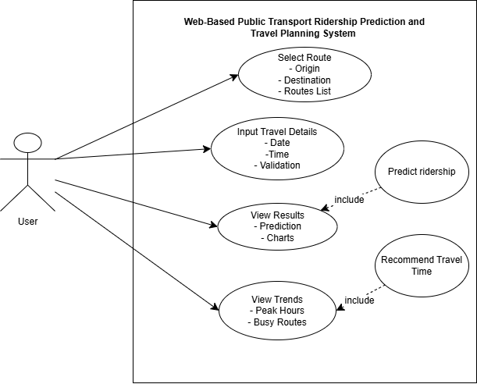
Figure 3: Use Case Diagram
Figure 3 demonstrates the ridership prediction system use cases, the interactions between the system functions and users.

3.7.3 Entity-Relationship Diagram
ERD is the logical form of the database that supports the system. The relationships between entities like Station, Route, Ridership and Prediction Result are through primary and foreign keys. Cardinalities show one to many and many to many relationship, which guarantee normalized schema design. This graphic gives a solid starting point of data storage and retrieval, which aids in proper machine learning predictions.
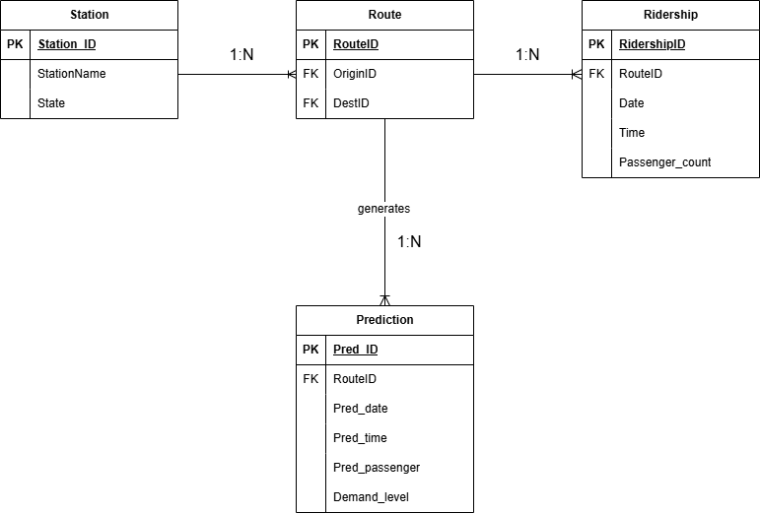
Figure 4: Entity-Relationship Diagram (ERD)
Figure 4 present the entity-relationship diagram of the system database, specifying the data structure and relationships in the database.
TABLE 3. 3: Entity Description
Entity | Primary Key (PK) | Description
Station | Station_ID | ETS railway stations
Route | RouteID | Connection between the stations.
Ridership | RidershipID | Historical passenger counts
Prediction | Pred_ID | Predicted ridership results

3.7.3 Data Flow Diagram
DFD shows the data flow in the system between the input and output. It reveals how the details about a trip posted by users are fed into the modules comprised of data preprocessing, prediction modelling and demand classification and finally as visualized results. Arrows represent the flow of data, making it transparent as to how information is converted and made available to the user.
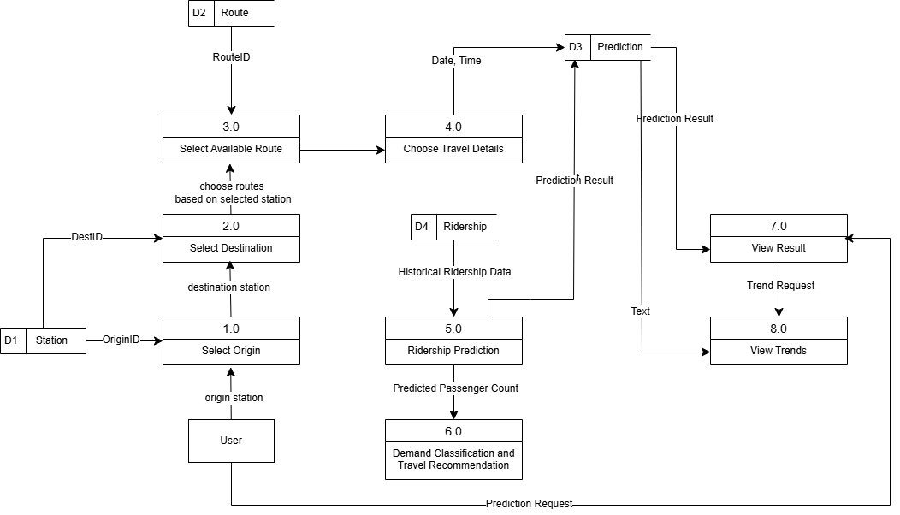
Figure 5: Data Flow Diagram (DFD)
Figure 5 shows the Data Flow Diagram of the data flow in the system at various levels.

3.7.4 Data Processing Pipeline

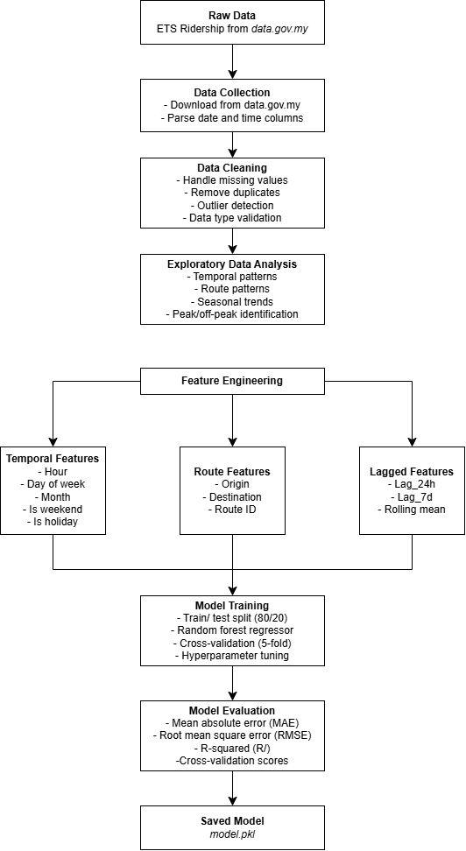
Figure 6: Data Processing Pipeline
The entire data processing pipeline including raw data acquisition, up to trained model output is shown in Figure 6.

3.8 System Implementation
System implementation will incorporate the components that have been developed into an operational web-based system that can be used by the users. The phase integrates the predictive model, the user interface, the visualization elements and the recommendation logic to form an integrated application. It is implemented in-line with web development best practices, coupled with performance and usability considerations to the end users.
The backend server in Web application architecture is Python Flask. The front end is developed with HTML, CSS and JavaScript to interact with the user. The system introduces the eight functional modules that are defined in Chapter 1: Route Selection, Travel Input, Historical Data Processing, Ridership Prediction, Demand Classification, Result Visualization, Travel Recommendation and Trend Analysis. The computational basis is offered by Python libraries such as Flask, Pandas, NumPy, and Scikit-learn.
The design of the user interface is such that it is easy to use and clear. Path choice offers the convenient dropdown menu with all ETS stations. A conventional picker interfaces available on various devices can be used to choose date and time. The interface is based on the principles of the responsive design of interface usability both on desktops and mobile devices.

3.9 Project Timeline & Summary

3.9.1 Project Timeline
A project schedule offers a structured point of view on the manner the Web-Based Public Transport Ridership Prediction and Travel Planning System can be accomplished in the allocated fourteen weeks. It specifies the main work areas, their sequence, and time each activity should take, making sure that work on the technical part and the creation of the report goes in parallel. The plan starts with Project Summary Draft in Weeks 1- 2 that forms the basis of the study. It is followed by Project Summary Review and Revision in Weeks 3-5 where the feedback is utilized to make adjustments to the premature plan. During Weeks 5 and 6, Proposal Writing in Chapter 1-3, including introduction, literature review, and methodology are covered. This step ends with Proposal Submission in Week 7. Proposal Defense and Correction in Weeks 8-9 is the next step that helps to evaluate the proposed methodology and refine it. Week 9 has the first technical experimentation in Data Collection and Preprocessing to prepare the ETS ridership data. Preliminary Training and Testing of the Machine Learning Model Weeks 10-11 Previous testing and training of the machine learning model during the 10-11 weeks determine whether the prediction model is viable. Weeks 11-12 will be followed by System Development and Integration to develop the web-based application. the documentation phase is Weeks 11-13 Project Report Drafting, to verify that all experimental results, and system design, is appropriately documented. Week 13 is then the final work done on the documentation and all the findings are condensed into the official report. The last one is Week 14 that entails Presentation Preparation and the final evaluation and defense.
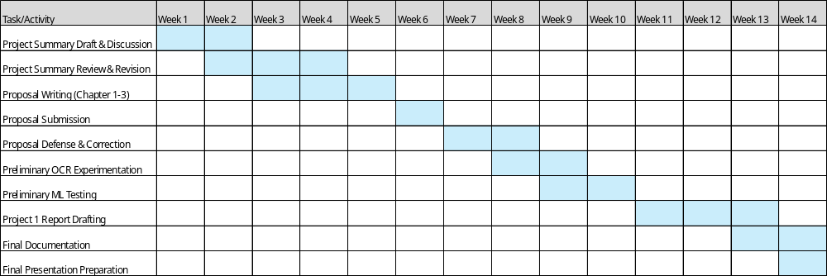
Figure 7: Gantt Chart of Project Timeline

3.9.2 Summary
This chapter has given the methodology that should be used to develop the ridership prediction and travel planning system. The project uses the CRISP-DM as a project management approach of Data Scientist. The methodology involves all the project stages, including data collection and implementation of the system. Data collection retrieves historical data on the open data portal by government on ridership. Preprocessing cleans and validates the data. The feature engineering constructs informative features used by models training. The machine learning models are developed and assessed using model development. System implementation puts together elements into a working web application. The figures below depict the system architecture, user flow, data processing pipeline and process of predictions.

